|  |  |
| --- | --- |
|  | **Airbnb** |

# **Product Dissection for Airbnb**

**Company Overview:**

Airbnb is a global online marketplace that connects travelers with hosts offering unique lodging experiences. Founded in 2008, Airbnb has transformed the way people travel by providing an alternative to traditional hotels. Its platform facilitates short-term rentals of apartments, homes, and unique properties worldwide, creating opportunities for cultural exchange and affordable travel.

**Product Dissection and Real-World Problems Solved by Airbnb:**

Airbnb has addressed several significant challenges in the travel and lodging industry through its innovative and user-centric features. Some of the key solutions include:

* **Access to Affordable and Diverse Accommodations:**

Traditional hotels can be expensive and limited in variety. Airbnb offers a broad range of property types—from shared rooms to entire homes—at competitive prices, catering to diverse budgets and preferences.

* **Building Trust and Ensuring Safety:**

With concerns about booking accommodations from strangers, Airbnb introduced verified profiles, user reviews, and secure payment systems. These features help build trust and ensure safety for both guests and hosts.

* **Simplifying the Booking Process:**

The platform features an intuitive search and filtering system, making it easy for users to find properties that match their specific needs (location, price, amenities, etc.). An integrated messaging system further streamlines communication between hosts and guests.

* **Facilitating Authentic Local Experiences:**

Airbnb not only provides a place to stay but also connects travelers with local hosts who can offer insights into the local culture and attractions, enriching the overall travel experience.

# **Case Study: Real-World Problems and Airbnb's Solutions**

**Problem: High Cost and Limited Choices of Traditional Lodging**  
*Real-World Challenge:* Many travelers find hotels expensive and lacking in diversity.  
*Airbnb’s Solution:*

* Offers a wide variety of accommodations—from shared rooms to entire apartments—across multiple price ranges.
* Provides detailed property descriptions, reviews, and photos to help users make informed decisions.

**Problem: Trust and Safety Concerns in Online Bookings**  
*Real-World Challenge:* Booking accommodations from strangers can be risky.  
*Airbnb’s Solution:*

* Implements verified user profiles and host reviews.
* Uses secure payment gateways and provides a messaging system to foster communication before booking.

**Problem: Complex and Time-Consuming Booking Processes**  
*Real-World Challenge:* Searching for and booking a property can be overwhelming.  
*Airbnb’s Solution:*

* Features advanced search filters (location, price, property type, amenities).
* Offers an intuitive interface that simplifies the booking process and improves user experience.

**Problem: Lack of Local and Authentic Travel Experiences**  
*Real-World Challenge:* Travelers increasingly seek immersive local experiences rather than cookie-cutter accommodations.  
*Airbnb’s Solution:*

* Encourages hosts to share local insights and recommendations.
* Connects guests with unique properties that reflect the local culture and lifestyle.

**Top Features of Airbnb:**

1. **Diverse Accommodation Listings:**  
   A wide range of properties—from budget rooms to luxury villas—ensures that travelers have many options.
2. **Advanced Search and Filtering:**  
   Users can refine searches by location, price range, property type, amenities, and more.
3. **Verified Reviews and Ratings:**  
   Transparent guest reviews help build trust and guide booking decisions.
4. **Secure Payment System:**  
   Integrated payment gateways ensure safe and reliable transactions.
5. **User-Friendly Interface:**  
   An intuitive design makes browsing, booking, and communication simple and efficient.
6. **Local Experience Integration:**  
   Hosts often provide local tips, recommendations, and unique experiences, enhancing the travel experience.

**Schema Description:**

The database schema for Airbnb is designed to capture the core entities and relationships that support its operations. Below is a summary of the primary entities and their key attributes:

* **Users Entity:**
  + **userID (PK):** Unique identifier for each user.
  + **Name:** Full name of the user.
  + **Email:** Registered email address.
  + **Role:** Indicates whether the user is a Guest or a Host.
  + **ProfilePicture:** URL or reference to the user's profile image.
  + **Verified:** Boolean flag for user verification status.
  + **CreatedAt:** Timestamp when the user registered.
  + **UpdatedAt:** Timestamp when user details were last updated.
* **Listings Entity:**
  + **listingID (PK):** Unique identifier for each listing.
  + **Title:** Title of the property listing.
  + **Description:** Detailed description of the property.
  + **Price:** Rental price of the property.
  + **Location:** Address or location details of the property.
  + **HostID (FK):** Reference to the user (Host) who listed the property.
  + **Amenities:** List of available amenities.
  + **Images:** URLs for property images.
  + **Status:** Current status (Active/Inactive).
  + **CreatedAt:** Timestamp when the listing was created.
  + **UpdatedAt:** Timestamp for the last update.
* **Bookings Entity:**
  + **bookingID (PK):** Unique identifier for each booking.
  + **userID (FK):** Reference to the guest who made the booking.
  + **listingID (FK):** Reference to the booked listing.
  + **CheckIn:** Date of check-in.
  + **CheckOut:** Date of check-out.
  + **BookingDate:** Date when the booking was made.
  + **Status:** Booking status (Confirmed/Cancelled/Completed).
  + **CreatedAt:** Timestamp when the booking was created.
  + **UpdatedAt:** Timestamp for the last update.
* **Reviews Entity:**
  + **reviewID (PK):** Unique identifier for each review.
  + **bookingID (FK):** Reference to the booking that generated the review.
  + **Rating:** Numeric rating (e.g., 1-5).
  + **Comments:** User’s feedback.
  + **ReviewDate:** Date when the review was submitted.
  + **CreatedAt:** Timestamp when the review was created.
  + **UpdatedAt:** Timestamp for the last update.
* **Payments Entity:**
  + **paymentID (PK):** Unique identifier for each payment.
  + **bookingID (FK):** Reference to the associated booking.
  + **Amount:** Transaction amount.
  + **PaymentDate:** Date of payment.
  + **PaymentMethod:** Method used (Credit, Debit, PayPal, etc.).
  + **Status:** Payment status (Pending/Completed/Failed).
  + **CreatedAt:** Timestamp when the payment record was created.
  + **UpdatedAt:** Timestamp for the last update.
* **Messages Entity:**
  + **messageID (PK):** Unique identifier for each message.
  + **senderID (FK):** Reference to the user sending the message.
  + **receiverID (FK):** Reference to the user receiving the message.
  + **MessageText:** Content of the message.
  + **SentAt:** Timestamp when the message was sent.
  + **ReadStatus:** Boolean flag indicating if the message has been read.
  + **CreatedAt:** Timestamp when the message was created.

**Relationships:**

* **Users and Listings:**  
  A Host (User) can list multiple properties; each listing is associated with one host.
* **Users and Bookings:**  
  A Guest (User) can make multiple bookings.
* **Listings and Bookings:**  
  A Listing can be booked multiple times over different periods.
* **Bookings and Reviews/Payments:**  
  Each Booking can generate one Review and is associated with one Payment record.
* **Users and Messages:**  
  Users can send and receive messages to facilitate communication regarding bookings.

**ER-Diagram:**  
The following ER diagram visually represents the schema design for Airbnb. This diagram illustrates the entities, their attributes, and the relationships between them.

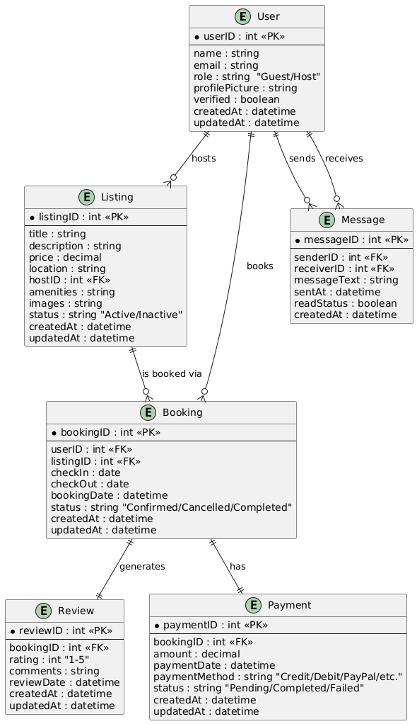

**Conclusion**

Airbnb effectively addresses real-world travel challenges by offering a platform that is affordable, trustworthy, and user-friendly. Its comprehensive features—from diverse accommodation listings to secure transactions and authentic local experiences—position Airbnb as a leader in the alternative lodging market. The robust schema design and ER diagram presented here underpin the platform’s functionality, ensuring data integrity, scalability, and a superior user experience.